**Biannual Lab care**

**Purpose:** Every six months our UV bulbs on the flow hood and biosafety cabinet as well as the HEPA and activated carbon filters on the vinyl anaerobic chamber must be changed.

**Materials:**

* UV bulbs, VWR , bulb General electric Preheat (Circuitry) T8, Cat# 47736-178
* HEPA filter canister, VWR, Pall HEPA filter canister, Cat# 28145-145
* Activated carbon filter canister, VWR , Pall Carbon capsule filter, Cat# 28145-702
* Permanent marker
* Adjustable wrench (check tool box)

**To change UV bulbs:**

Note: This must be performed on both the laminar flow hood and the biosafety cabinet

* Gently twist the old UV bulb toward you and remove from the fixture
* Place the old bulb safely off to the side
* Gently and carefully remove new UV bulb from the packaging
* Using a permanent marker write the date on both of the silver caps at the ends of the bulb
* Insert the bulb into the fitting and gently twist it away from you to secure it in the fixture
* Close/replace the sash and test the bulb by turning on the UV light. If it turns on (takes a second) it has been installed correctly
* Take the spent UV bulb and place it into the cardboard container that the new bulb came in. Write, “Trash spent bulb” on the side of the box and place it off to the side somewhere safe and out of the way of general lab traffic.
* Request to have the old bulbs disposed of through EHS:
  + Bring bulbs inside of container over to the satellite accumulation area (near chemical hood in NE-47-335)
  + Label container holding bulbs with a hazardous waste tag
  + Go online and submit a waste collection request on the EHS website (http://ehs.mit.edu/site/content/chemical-waste-collection-form)
* Order a new bulb so you will have one for the next change without being surprised

**To change HEPA and activated carbon filters:**

Parts (just in case something breaks in the future):

* Hose barb valved in-line coupling body (1/4”) , CPC, Part# PLCD17004
* Hose barb valved in-line coupling insert (1/4”) , CPC, Part# PLCD2200406
* PTFE Thread seal tape, Millrose, Part# 70661
* Nylon 3/8 MPT x ¼ hose barb fitting, Hypro, Part# A3814

To change HEPA and activated carbon filters:

Note that this will need to be done for both the HEPA and activated carbon filter canisters.

* Note the direction of the flow for each canister. This is indicated on the canisters themselves
* Press the silver catch releases (see below) on the coupling bodies (these connect the filters to the vacuum line) to release the old canister.

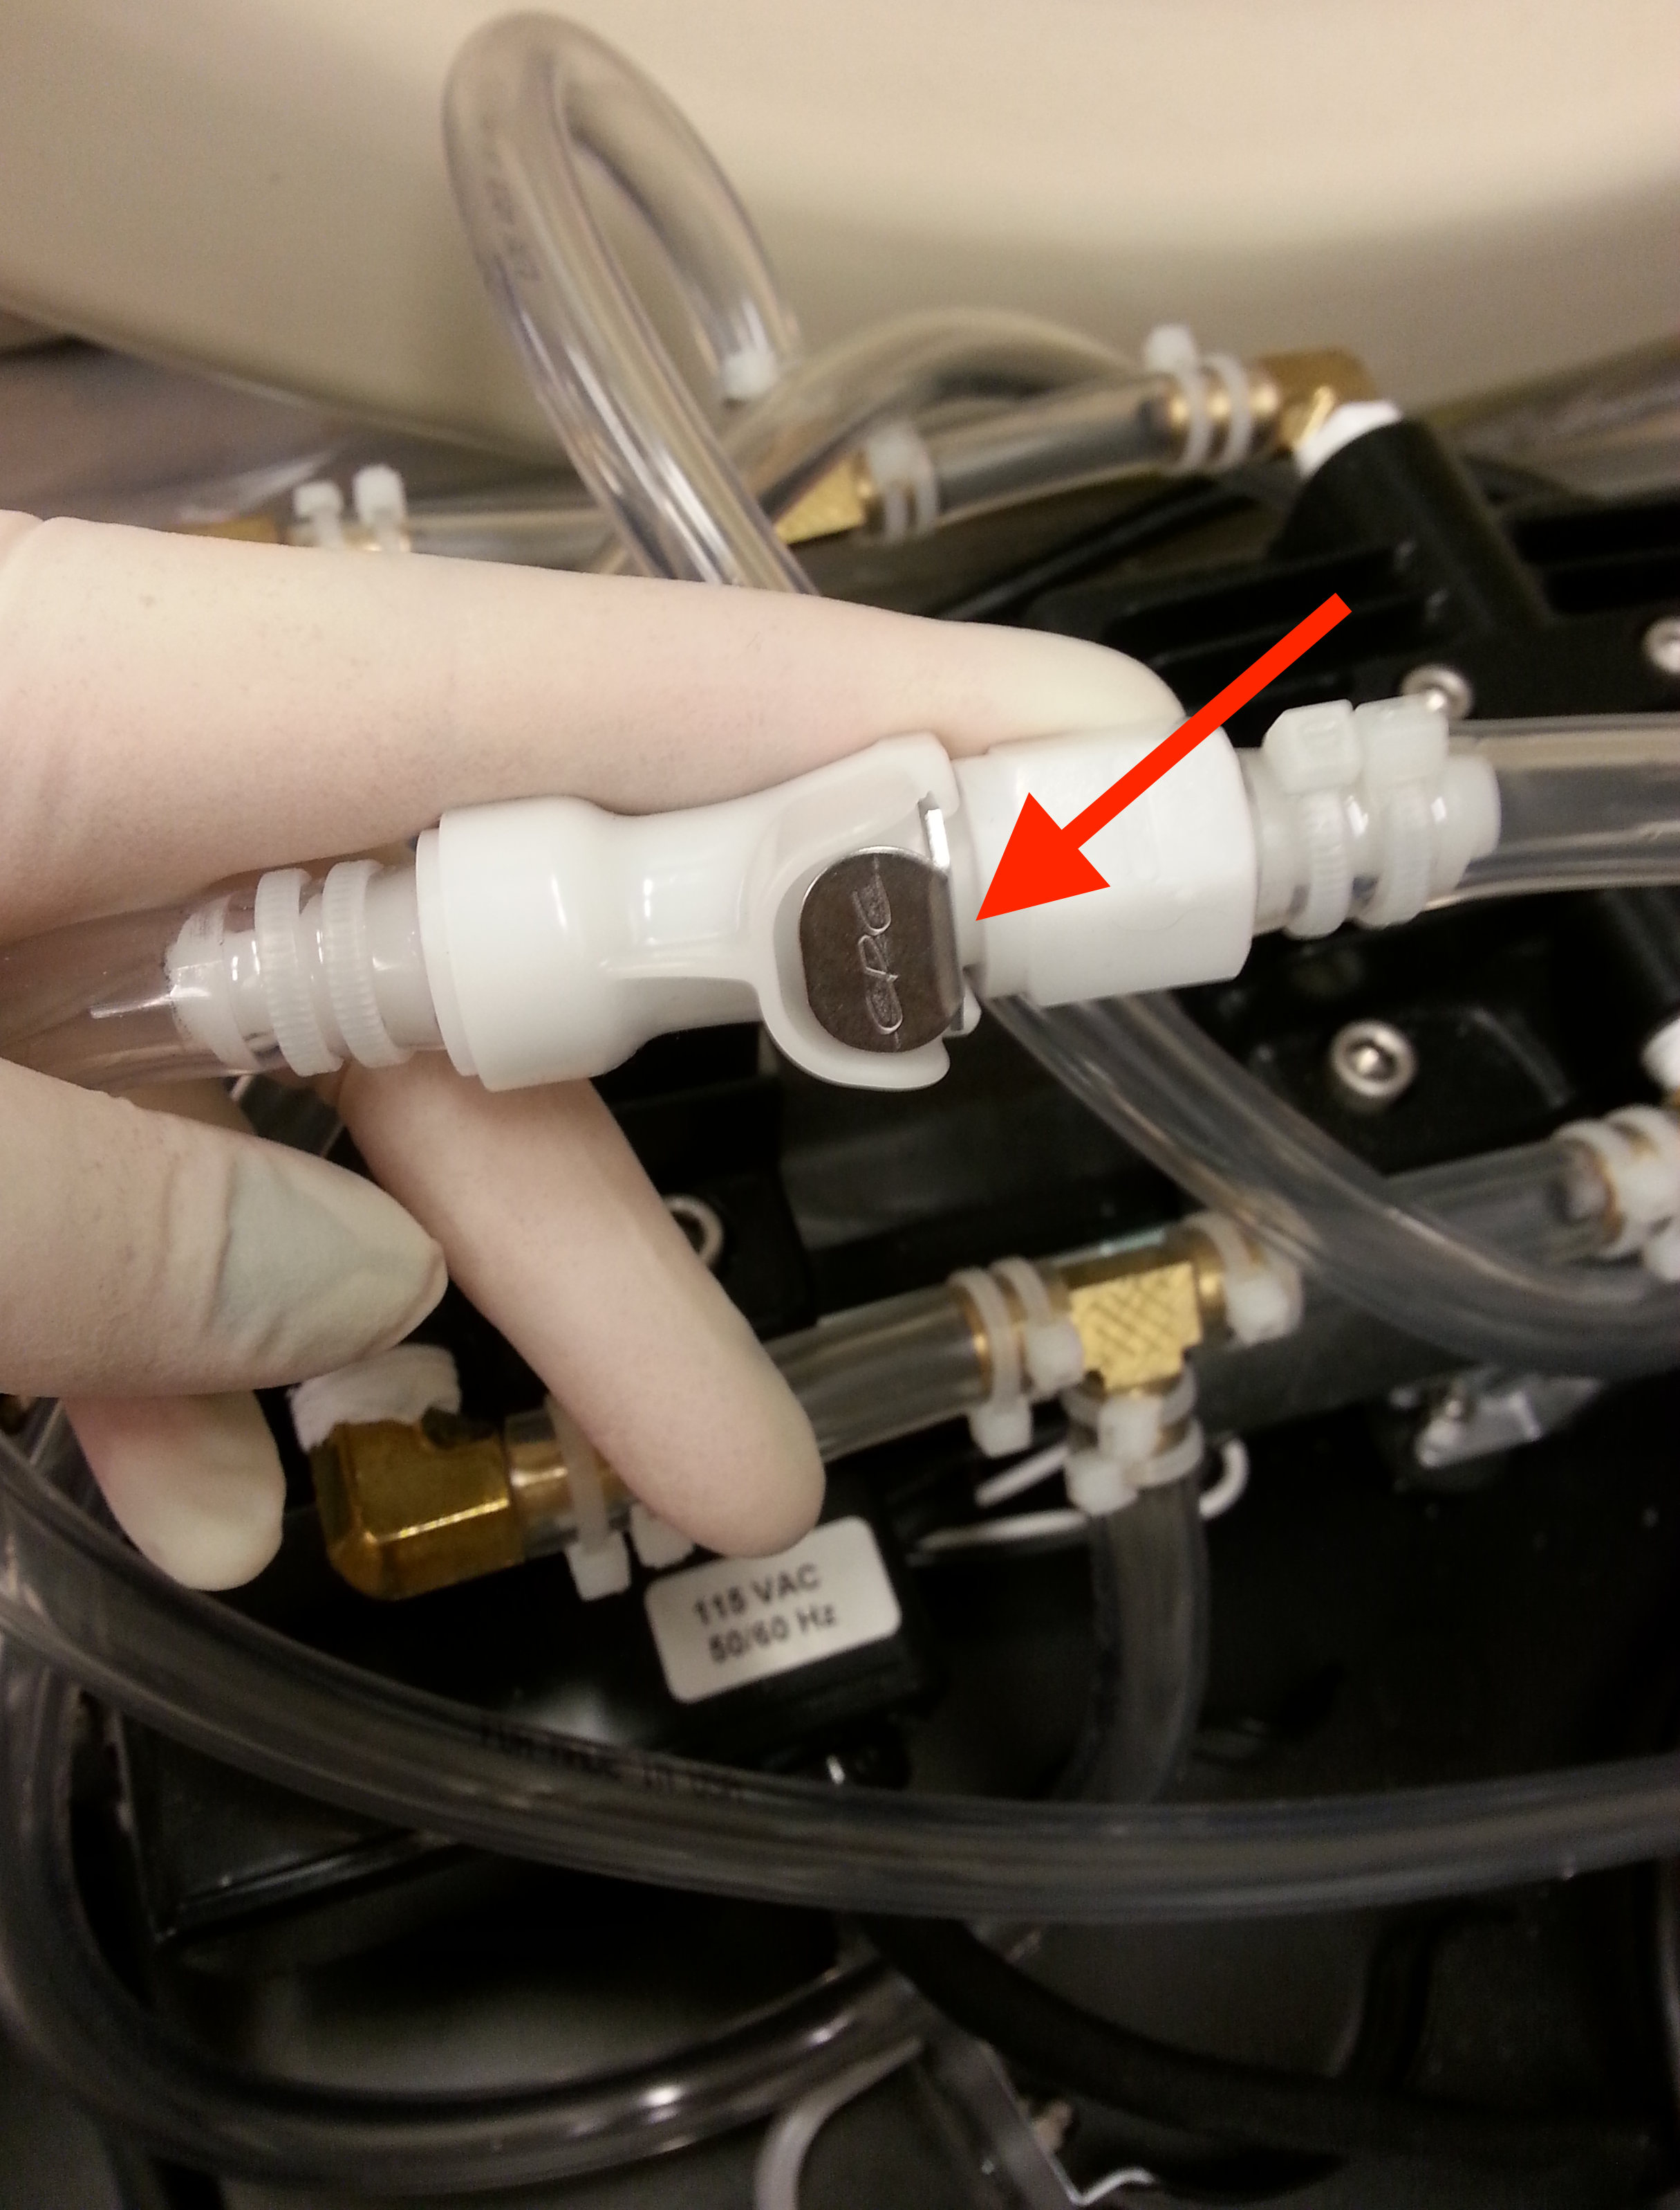 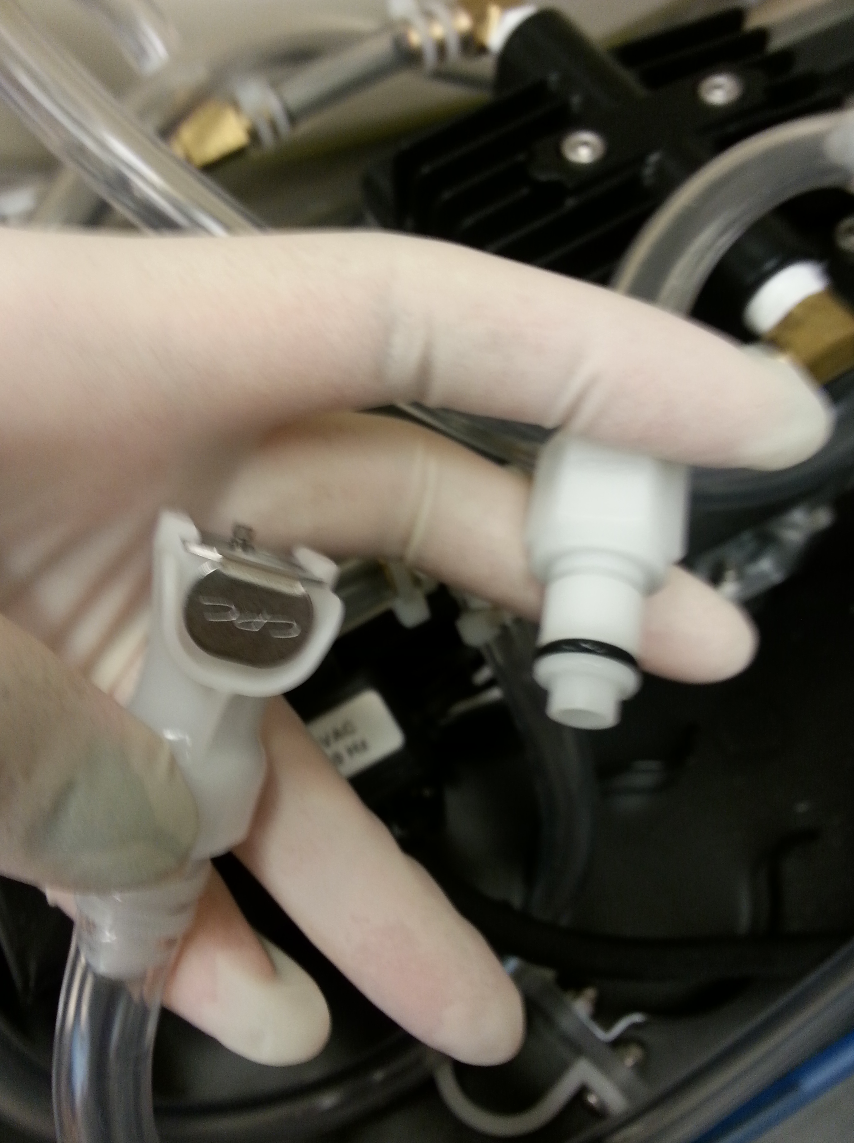

* Use a wrench to gently unscrew the threaded hose barb fittings from either ends of the canister (shown below). These connect the canisters to the couplings.

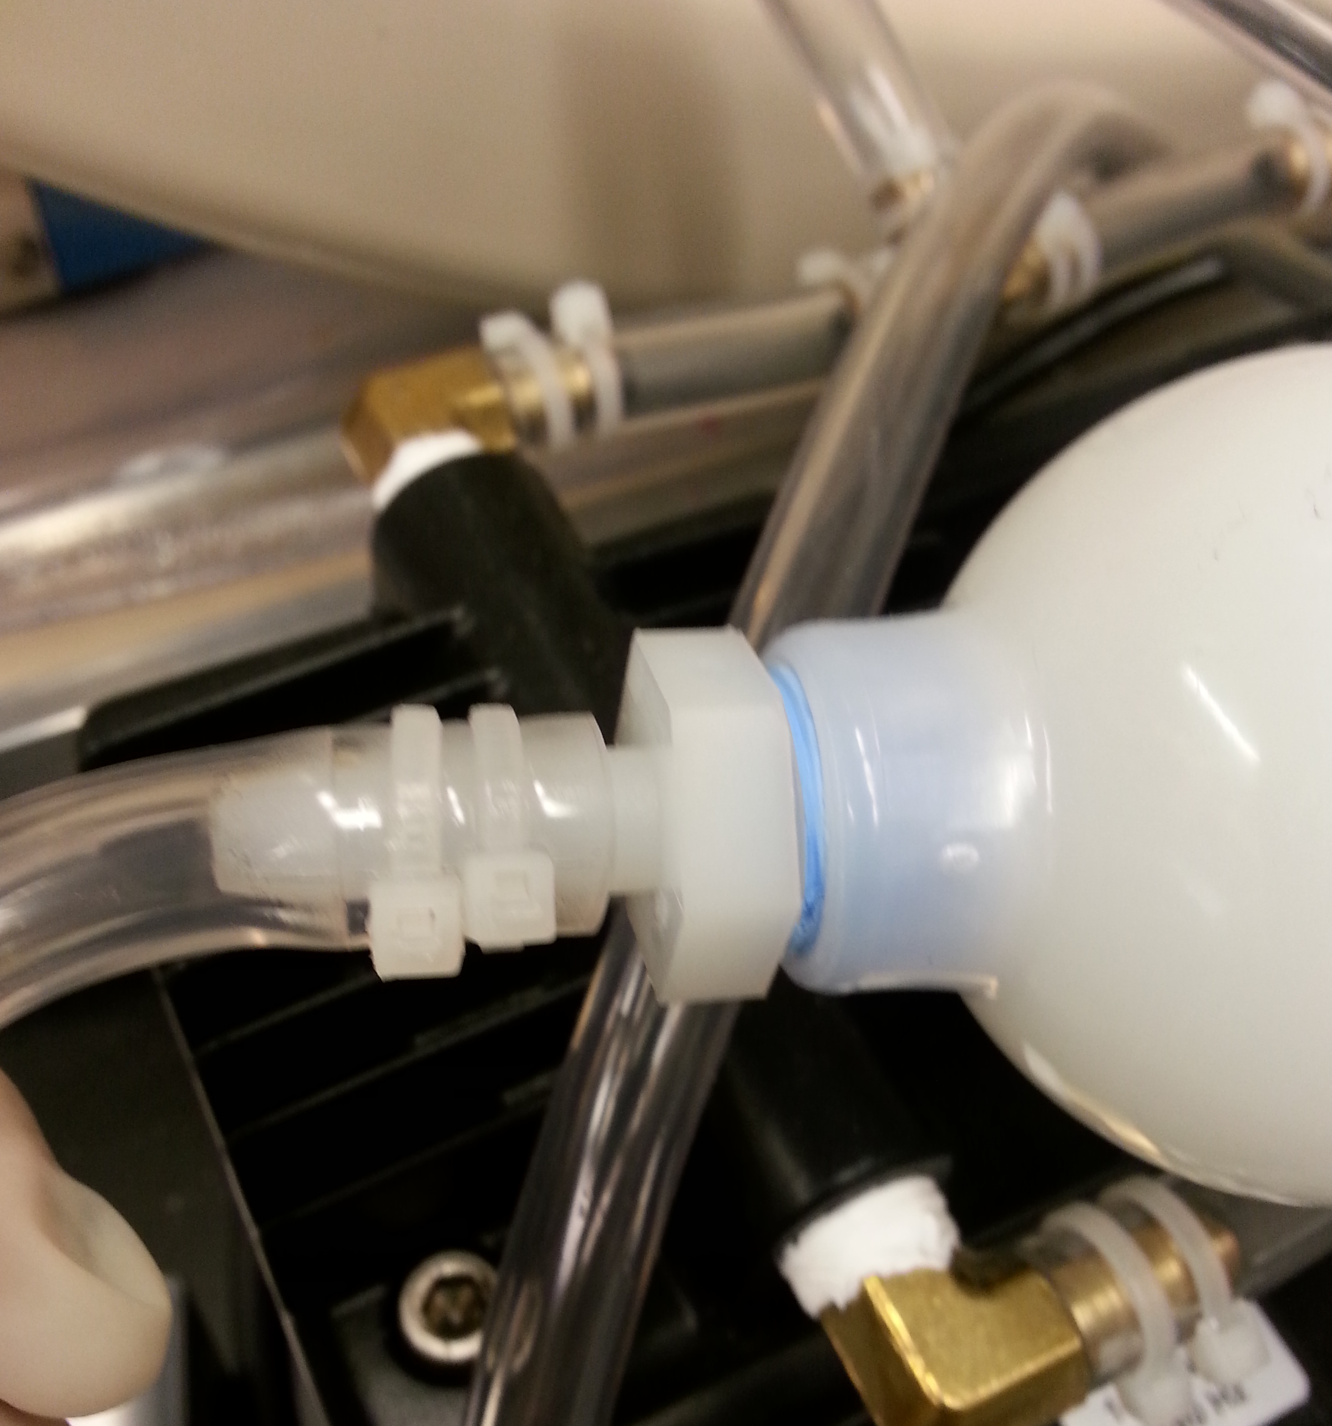

* Dispose of the old canisters in the biohazard waste bins
* Write the date on new canisters.
* Use the wrench to screw the hose barb fittings into the new canister (pay attention to the direction of flow!)
* Reattach the coupling bodies on either end of the canister (you will need to press the metal button in order to do so). Make sure that the insert is fully inserted into the body
* Done! Thanks for keeping the lab up to date ☺